EXPERIMENT 4

CREATE TABLE STUDENT_50A(ROLL_NO INT PRIMARY KEY, PHYSICS INT, CHEMISTRY INT, MATHS INT);

SELECT * FROM STUDENT_50A;

INSERT INTO STUDENT_50A VALUES(1,24,23,49);
INSERT INTO STUDENT_50A VALUES(2,22,25,48);
INSERT INTO STUDENT_50A VALUES(3,24,22,47);
INSERT INTO STUDENT_50A VALUES(4,20,25,50);
INSERT INTO STUDENT_50A VALUES(5,25,23,47);
INSERT INTO STUDENT_50A VALUES(6,24,23,50);
INSERT INTO STUDENT_50A VALUES(7,22,25,47);
INSERT INTO STUDENT_50A VALUES(8,25,24,50);
INSERT INTO STUDENT_50A VALUES(9,24,23,49);
INSERT INTO STUDENT_50A VALUES(10,25,23,48);

ALTER TABLE STUDENT_50A ADD(PASS_FAIL VARCHAR(55));

UPDATE STUDENT_50A SET PASS_FAIL ='PASS' WHERE ROLL_NO=1;
UPDATE STUDENT_50A SET PASS_FAIL ='PASS' WHERE ROLL_NO=2;
UPDATE STUDENT_50A SET PASS_FAIL ='PASS' WHERE ROLL_NO=3;
UPDATE STUDENT_50A SET PASS_FAIL ='PASS' WHERE ROLL_NO=4;
UPDATE STUDENT_50A SET PASS_FAIL ='PASS' WHERE ROLL_NO=5;
UPDATE STUDENT_50A SET PASS_FAIL ='PASS' WHERE ROLL_NO=6;

UPDATE STUDENT_50A SET MATHS= '20' WHERE ROLL_NO=7;
UPDATE STUDENT_50A SET PHYSICS= '11' WHERE ROLL_NO=8;
UPDATE STUDENT_50A SET CHEMISTRY= '10' WHERE ROLL_NO=9;
UPDATE STUDENT_50A SET MATHS= '18' WHERE ROLL_NO=10;

UPDATE STUDENT_50A SET PASS_FAIL ='FAIL' WHERE ROLL_NO=7;
UPDATE STUDENT_50A SET PASS_FAIL ='FAIL' WHERE ROLL_NO=8;
UPDATE STUDENT_50A SET PASS_FAIL ='FAIL' WHERE ROLL_NO=9;
UPDATE STUDENT_50A SET PASS_FAIL ='FAIL' WHERE ROLL_NO=10;

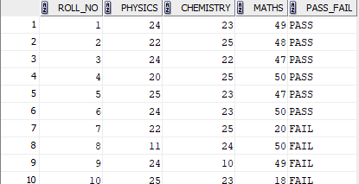

Q1:
SELECT AVG(PHYSICS) FROM STUDENT_50A;
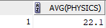

Q2;
SELECT MAX(MATHS) AS highest_marks_maths FROM STUDENT_50A;


Q3:
SELECT MIN(CHEMISTRY) AS lowest_mark_chemistry FROM STUDENT_50A;
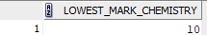
Q4:
SELECT COUNT(ROLL_NO) AS PASS_PHYSICS FROM STUDENT_50A WHERE PHYSICS>=12;
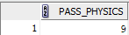

Q5:
SELECT * FROM STUDENT_50A
WHERE PHYSICS>=12 AND CHEMISTRY>=12 AND MATHS>=25;
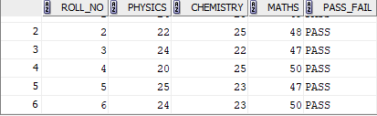

Q6:
SELECT ROLL_NO,( PHYSICS+ CHEMISTRY + MATHS) AS TOTAL ,PASS_FAIL FROM STUDENT_50A
ORDER BY TOTAL DESC

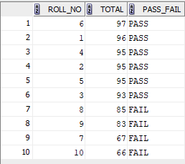

Q7:

